Installation instructions:
- Click here to visit the itch.io page in order to download the game.
- Download and place the following into any folder together
  - ASLFARM.exe
  - ASLFARM.pck
- Once both have been downloaded, run ASLFARM.exe to play the game
System Requirements:
- OS : Windows 10+
- PROCESSOR: 2 Ghz
- MEMORY: 4 GB RAM
- GRAPHICS: 128MB, OpenGL 3+
- STORAGE: 200 MB available space
UI Overview:
Main Menu: This is what the game should look like when you run ASLFARM.exe
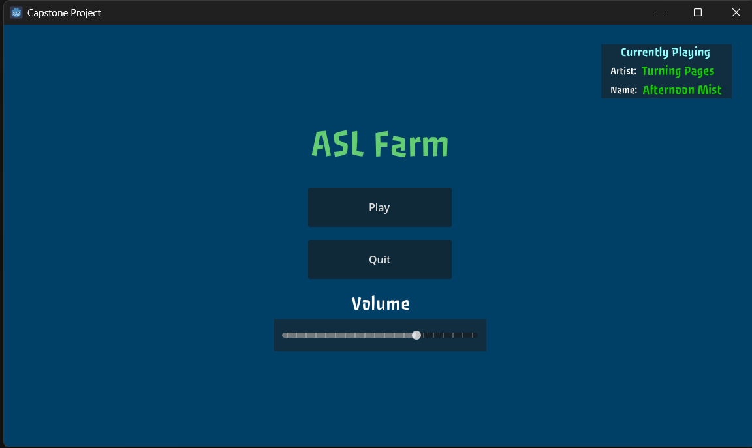

Home Scene: This is what the start of the game will look like when you click play.
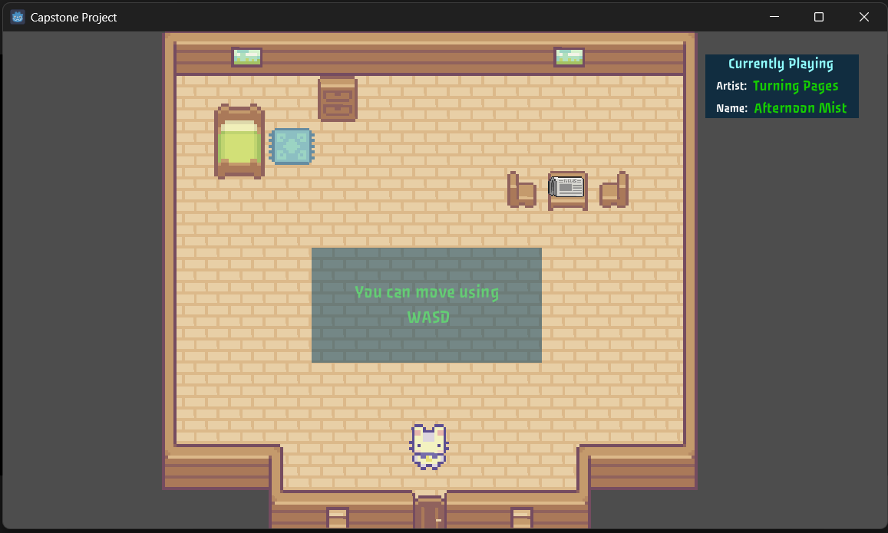

Farm Scene: This is what you will see when you leave the house
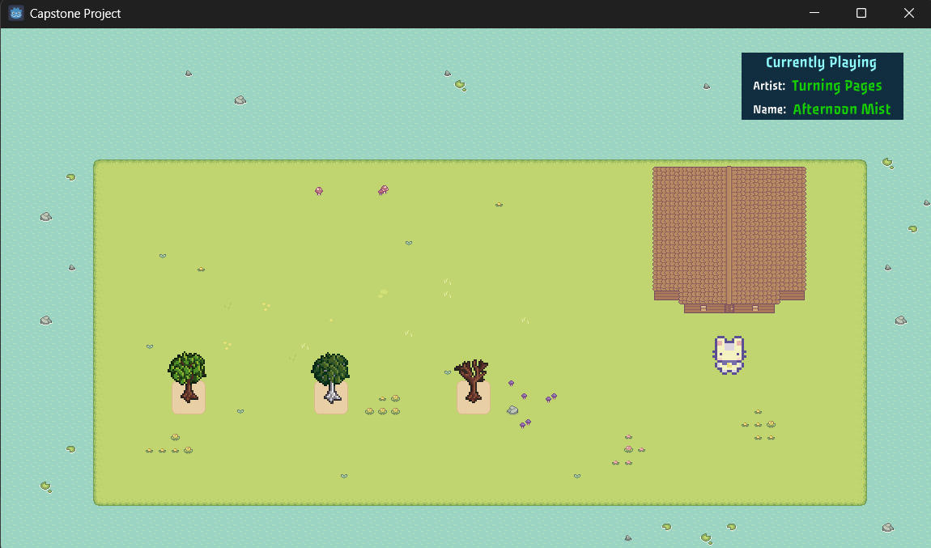

Pause UI: This is what the user will see when they press “Escape”

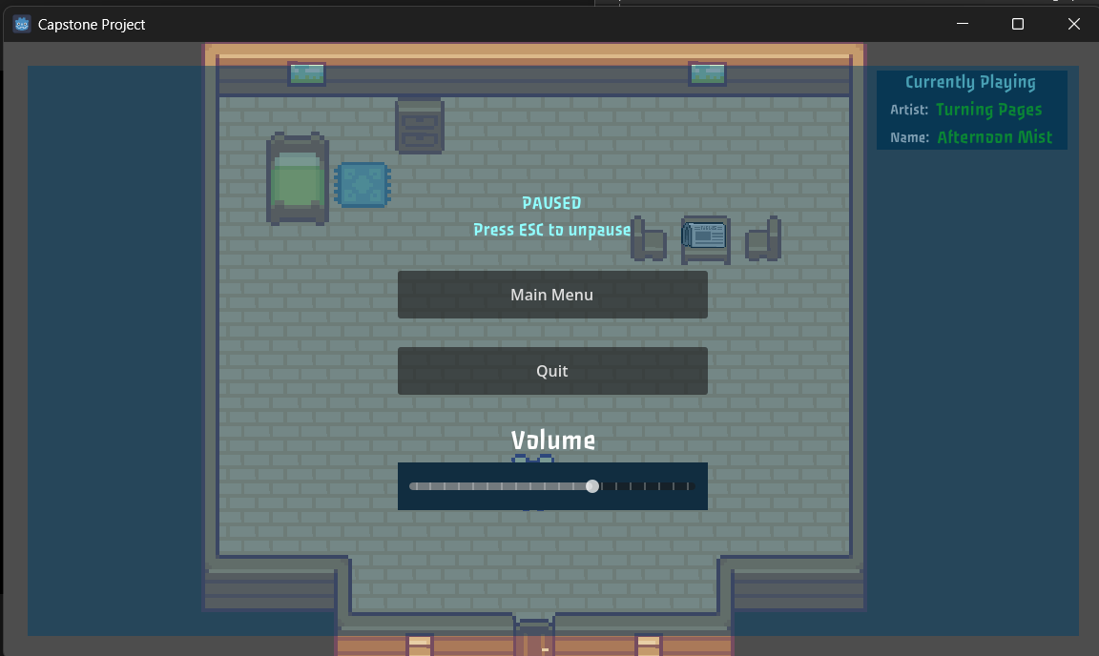

Software Use:
To use this software, you just need to run the executable and follow the tutorial when you first start the game. The in-game tutorial will guide you as to what you must to do make progress and learn new ASL Signs.

